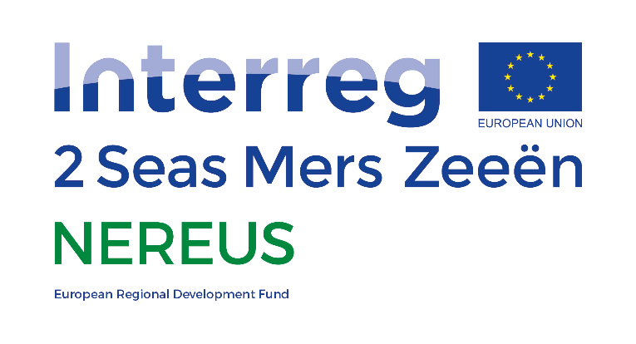



8th November 2021

HZ University of Applied Sciences

Emma.mcateer@hz.nl

Social Acceptance of Recovered Products

Deliverable D2.5.3

This project has received funding from the Interreg 2 Seas programme 2014-2020

co-funded by the European Regional Development Fund under subsidy contract No 2S03-011.

Contents

1 Introduction 2

2 Recovered Products: DuCoop 3

2.1 Drivers and concerns for living at the Nieuwe Dokken 3

2.2 Sustainability awareness 3

2.3 Public acceptance of recovered resources 4

2.3.1 Water 4

2.3.2 Nutrients 4

3 Recovered Products: CAPSO 5

3.1 Benefits and constraints of agricultural spreading 5

3.1.1 Environmental concerns 6

3.2 Social acceptance 6

3.3 Looking forward 7

4 Conclusion 7

5 References 7

# Introduction

The NEREUS project has focused for the last four years on the recovery and reuse of several resources from urban wastewater. A lot of time and effort has been invested in ensuring the technological success when it comes to recovery of resources. The success of each technology regarding recovery can be found in the NEREUS final reports D2.4.1, D2.5.2 and D2.6.1.

Aside from the actual recovery of the resource, there is also the question of reuse of the product once recovered. Each pilot case within the project aimed to recover various resources with differing end uses. In the original plan for the project, Waterlink aimed to recover drinking water, Evides aimed to recover irrigation water for urban farming and Southern Water aimed to recover struvite, to name but a few examples.

The goal of this report is to summarize evidence and experiences gathered during the project on the topic of social acceptance, i.e. the resource may be recovered and ready for reuse, but how does the end user feel about using them, knowing where they originated?

Originally, the plan was for this report to cover the willingness of consumers to apply recovered wastewater as irrigation water for edible crops and the willingness of consumers to drink drinking water recovered from wastewater. However, due to some external influences during the project period, neither of those goals could be realized. The pilot location for Evides called Uit je Eigen Stad where the irrigation water would be produced and used, went bankrupt during the project meaning that Evides had to move to a different pilot location. This also meant that the end water use for Evides changed and the investigation into the willingness of the public to apply recovered irrigation water to edible crops could no longer be carried out.

The corona virus pandemic also had an impact on this deliverable; the pilot location belonging to Waterlink called Plein Publiek, where the drinking water would be produced and served, had to close down during the pandemic. Eventually Waterlink decided to also move pilot location and to also change their water end use. Therefore, no drinking water has been or will be produced during the timeframe of the project and therefore willingness to drink it could also not be tested.

Even though the original goals for this deliverable on the reuse of water could not be met, there are other resources recovered by other partners in the project that could be investigated on public acceptance.

This report therefore summarizes the findings of two partners; DuCoop and CAPSO when investigating the public acceptance of their end recovered product. CAPSO recovers dried sludge from a wastewater treatment plant which is used as fertilizer by local farmers. DuCoop recovers several resources which are reused within the housing complex where the treatment plant is situated; biogas, heat energy and water.

# Recovered Products: DuCoop

In October 2018 DuCoop organized three focus groups with the future residents of the Nieuwe Dokken district, where the pilot wastewater treatment plant would be located. The aim of the sessions was to ascertain the current knowledge and expectations of the residents about DuCoop’s sustainability services. In this way and through the specifically posed questions, DuCoop were also able to get an insight into the acceptance level of the residents when it comes to reuse of recovered resources within the building. The report written by DuCoop on 25th January 2019, concluding the findings of the focus group sessions, has been summarized and used in this report as a reference for experiences surrounding public acceptance of recovered resources.

The focus groups consisted of 21 people in total, made up of a mix of couples, individuals, residents with and without children and landlords with the aim of renting out their properties.

## Drivers and concerns for living at the Nieuwe Dokken

During the sessions, the participants were asked about why they wanted to live at the Nieuwe Dokken and also what concerns they might have about living there. The responses were primarily positive; the draw of the location close to the city, at the waterside and with such a good view was a main factor as well as the sustainable character of the district. There was a feeling of pride and responsibility with being a property owner at the Nieuwe Dokken and the fact that DuCoop’s sustainability services meant that the residents can leave the complex decision making regarding sustainability to someone else was seen as a positive.

The concerns about living at the Nieuwe Dokken were mainly related to noise pollution from the nearby roads and schools and the centrally located kitchen waste grinder; which the participants thought would likely be frequently used, but there were some concerns regarding cleanliness and keeping the area hygienic.

## Sustainability awareness

In general most of the participants were aware of the challenges of climate change and want to act accordingly but don’t know how to do this on an individual basis. Those who are more informed on sustainability also feel the pressure of too much choice; decisions become more complex due to the availability of so much information. For this reason, the actions of a sustainability cooperation like DuCoop are strongly supported; choices are made easier for the resident while causing little to no discomfort. Some participants had difficulties with the changes such as a vacuum toilet but could accept them if their loss of comfort is minimal and it benefits the greater good; for example better operation of the wastewater treatment plant.

The participants were also positive about the proposal of the Web-based user platform ´MyDuCoop”, used for monitoring water, electricity and heat usage. This platform would enable residents to keep track of their progress and also help to compare to the progress of other buildings.

## Public acceptance of recovered resources

The participants were also questioned on the specific sustainability services of DuCoop; they were asked to fill in a scoring card about the sustainability services. Participants had to score each service from 1 to 5 in order of importance (1 being the lowest). The services included:

* Reduce the toilet water consumption through the use of vacuum technology
* Reuse of water through local wastewater treatment
* Use and distribution of locally produced renewable energy
* Reuse of nutrients from waste streams
* Distribution of heat from residual heat
* Offering energy for mobility applications
* Processing kitchen waste through local wastewater treatment

The result was that participants found it hard to score as they found all services to be important. The services that seemed to be recognized as most important were; heat network, local sanitation and vacuum toilets. The least important are reuse of nutrients from waste, local processing of kitchen waste and distribution of energy for mobility. There was no severe criticism given to any of the services; only nutrient recovery was not accepted by one participant; unfortunately there was no reason given for this.

From a practical perspective, the use of the kitchen waste grinder was also seen as positive as some participants explained that by using the kitchen waste grinder instead of not separating food waste, there will be less weight in the general household waste and it will therefore cost less.

### Water

When it comes to the use of recovered water from wastewater, the responses were positive. Participants have good faith in technology and can accept recovered water as drinking water as long as it has been regarded as safe under law and with sufficient quality controls. Recent water scarcity periods (summer droughts) increase the awareness of the need to be more responsible with water and therefore also contribute to a more positive public acceptance of using recovered water.

### Nutrients

When it comes to the reuse of nutrients, even though this was one of the sustainability services that scored lowest on the scoring cards, participants were generally positive about reusing nutrients as fertilizer locally. They don’t see much difference in reusing nutrients recovered from a wastewater treatment plant and common practices like adding animal manure to agricultural land, although the perception is different. They did raise the point that an end product quality check is very important here and suggested that showing successful examples of recovered fertilizer being used in urban farming would greatly increase acceptance. The point was also made that they would like to see the city authorities take a leading role in the reuse of recovered fertilizer in urban gardening in the city.

# Recovered Products: CAPSO

CAPSO’s pilot focused on the sludge stream coming from the Saint-Omer wastewater treatment plant (WWTP). The goal was to improve sludge siccity and quality for safer storage, reduced pollution potential and use as a more effective fertilizer. By using lime in their process, they improved the sludge’s characteristics for subsequent use, converting it into a biosolid product for soil conditioning, reducing odour and enhancing its agricultural benefits by maintaining the nutrient bio-availability.

In 2020, 11 farmers received sludge from the pilot to be used for spreading on their fields. This represented around 3600 tonnes of raw (wet) sludge and an average dose of 17.4 tonnes per hectare of land.

Before the sludge was spread on the land, a spreading plan was drawn up which would identify the farmers’ concerns as well as the particular plot of land set to receive the sludge. A soil analysis was carried out in order to determine the characteristics of the receiving soil which would ultimately control the quantity of sludge that could be spread. Local regulatory bodies have established limits and requirements concerning certain parameters which was also taken into account in the plan, for example; in some areas a maximum quantity of 200Kg/ha Nitrogen can be spread.

Ongoing monthly analyses are carried out on the sludge to determine its composition and therefore conclude the quantities that can be spread on each plot of land.

The sludge produced at the WWTP throughout the year is stored in a storage area. A partner company manages the operation of this area including monitoring, sludge analysis and spreading. De-stocking of the storage area is performed twice a year.

CAPSO themselves wrote up an analysis of social acceptance based on their experience of the pilot to date and the known benefits, constraints and risks involved in the process. This analysis has been summarised and used as a reference for the benefit of this report.

## Benefits and constraints of agricultural spreading

The sludge coming from WWTPs is of interest for agricultural use because it contains a high content of organic matter and mineral elements (nitrogen, phosphorus, potassium, etc.).

In sludge such as that supplied by CAPSO to farmers, nitrogen is in organic form and will therefore be available to plants in the long term. In addition, the contribution of phosphorus by the sludge is very important, and almost equal to that of chemical fertilizers.

The advantages of spreading are both of a practical and economic nature. It is practical because its implementation does not require any extra specific investment in terms of machinery or processes. The only thing required is a spreader which many farms should already have.

It is also economical because it allows direct return of organic waste to the ground without any additional cost incurred for treatment or product transformation.

Another economic element is the saving for farmers on the purchase of extra fertilizers; as the sludge itself is a supply of fertilizing elements contained in the organic matter (N, P, K, Ca, Mg, S).

However, there are also constraints to sludge spreading:

1. Spreading cannot take place in all seasons and in all places (spreading only in March-April before sowing, or in August-September after harvest)
2. There is a level of agronomic[1] monitoring required to ensure that the right amount of nutrients are spread in the right place, in order to respect the soil and the environment
3. The spreading of WWTP sludge has an agronomic impact on agricultural land; an increase in the organic matter content of the soil has a subsequent impact on the properties of the soil and its fertility

### Environmental concerns

Spreading of sludge can present environmental risks, namely in the form of pathogenic microorganisms, metallic trace elements and persistent organic pollutants.

Pathogenic microorganisms are present in raw organic products and can be considered a concern when wanting to reuse these products in agriculture. However, at the CAPSO pilot, the sludge is limed to remove this risk; the addition of quicklime to the sludge generates an exothermic reaction which releases heat that kills off these micro-organisms. In addition, the lime also improves soil fertility.

Metallic Trace Elements are found naturally in soils, some of these elements are essential trace elements for the life of plants and animals for which the balance between deficiency and toxicity must be found. Examples of these include Boron, Copper, Cobalt, Iron, Manganese, Nickel, Selenium, Zinc. However, there are others that are potentially toxic to living organisms, such as; Mercury, Lead, Arsenic and Cadmium. Regular analyses are performed on both the sludge and the soil to ensure that this balance is kept and compliance with regulatory thresholds for these toxic elements are met.

Organic Trace Compounds are persistent organic pollutants resulting in particular from pesticides, hydrocarbons and detergents or resulting from their degradation. These molecules can also be found in WWTP sludge and are analyzed to ensure that their concentrations do not exceed authorized standards before spreading on soil.

## Social acceptance

As can be seen, there are several constraints and potential environmental impacts when considering the spreading of WWTP sludge on agricultural land, which could lead to a negative uptake in terms of social acceptance. However, the experience of CAPSO to date with their pilot has been that the agronomic interest (benefit to the land and the crops) coupled with the economic interest has led to a positive social acceptance despite the potential risks.

It is relevant to note that for this particular pilot case, VEOLIA, who are the sub-contractor involved with the CAPSO case, have developed a long-term relationship with the farmers involved. A personalized working programme has been set up between the two parties along with a partnership contract which allows VEOLIA to analyze the soil, determine where and how the sludge can be spread and prepare a tailored mix according to the farmers expectations but also to the characteristics of both sludge and the soil. The contract is revised every year enabling a close control of the lime concentration and its effect on the fields where it is spread, on a long-term basis.

This has led to the number of farmers trusting this circular process slowly increasing throughout the years but it still remains a fragile balance between the desire for sustainable practices and the potential risk of using organic wastes from urban sanitation.

## Looking forward

Besides the present risks already mentioned, there could be some emerging risks that need to be considered in the future. These include fears about the danger of micro-pollutants such as heavy metals, drug residues, endocrine disruptors, detergents and micro-plastics. Whether or not WWTPs will be able to treat and remove these effectively is a future concern as these WWTPs are often designed for treatment of organic materials and not necessarily chemicals or micro-pollutants.

New and emerging risks could pose a challenge not only for the WWTPs but also for the communities and potential end users, such as farmers in this case. One recent example is the corona virus pandemic and the doubt it has exposed in terms of existence of the virus in WWTPs and potential contamination. This has opened up debate about these challenges and how to combat them; regulatory obligations and also adaption of WWTPs which brings with it infrastructure and maintenance costs; another challenge. It is important to mention this in the discussion of social acceptance as something that will need to be dealt with in the future.

# Conclusion

After analyzing the two pilot cases who did investigate social acceptance of their end products, it can be said that both pilots encountered both benefits and constraints regarding reuse of the recovered resource. It is clear that the public are aware of where the resource is coming from and the associated risks regarding the environment and health.

In the case of DuCoop, a slight hesitation was experienced in regard to the reuse of nutrients as a fertilizer but enough faith was put in the legal requirements, technology and monitoring protocols to overlook this and ultimately accept the end product, especially considering the overall benefit.

In the case of CAPSO, the environmental risk factors are also well known but in the perception of the public (farmers in the pilot) these are far outweighed by the benefits for the land and the economical savings.

To conclude; public acceptance of the end products for both of these pilots can be considered positive and successful.

# References

Demolder, L., De Smet, P., Seuntjens, D. (2019). *Focus group DuCoop.* DuCoop

Dumont, M., Monsterleet, C., Courouble, S. (2021). *Report on social acceptance – Pilot CAPSO (O14)*. CAPSO



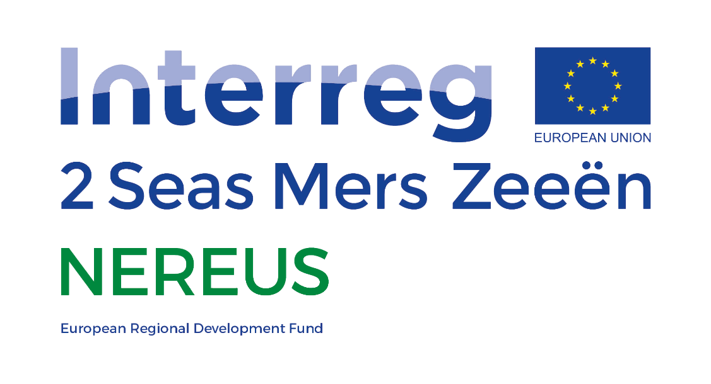



This project has received funding from the Interreg 2 Seas programme 2014-2020

co-funded by the European Regional Development Fund

under subsidy contract No 2S03-011.

1. *Agronomy is defined as the science of soil management and the production of field crops* [*https://www.dictionary.com/browse/agronomic*](https://www.dictionary.com/browse/agronomic)